Mr. Obang’s Response to the Postponement of the Filling of the Grand Ethiopian Renaissance Dam (GERD)
June 26, 2020

Today I am in Gambella, sometimes called “the land divided by the rivers.” Gambella region is located in the Upper Nile, an area that overlaps both Ethiopia and South Sudan. It is a land of five major rivers and many tributaries that connect to the Nile River. It used to be a port that could be used for transportation all the way north to Egypt.
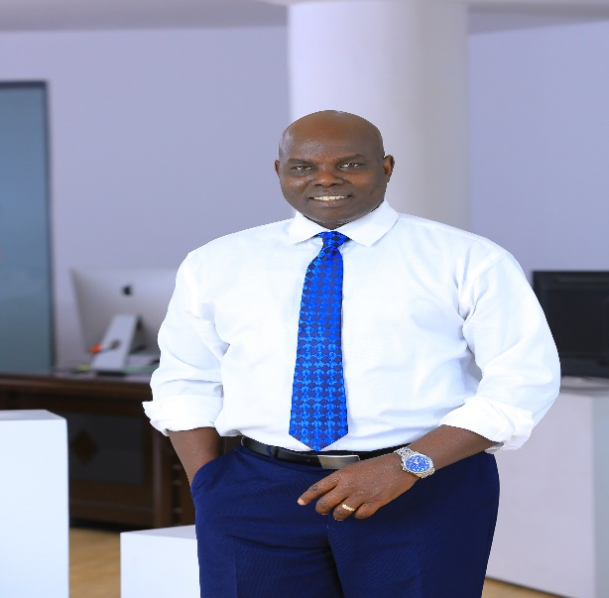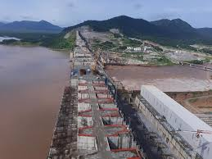

I have just learned that the Ethiopian government has agreed to a two week postponement of the filling of the Grand Ethiopian Renaissance Dam (GERD). I am very disappointment with this decision. Let me explain.

From the beginning in 2012, Egypt has exerted significant pressure against the construction of this dam meant to bring electricity to Ethiopians—- some 60% of whom lack access. Electrical power, in excess of the needs of Ethiopia, will also be sold to supply other neighboring countries, like Sudan, with needed electricity. On the other hand, Egypt already possesses its own sources of hydroelectric power due to dams they have built, like the Low Aswan Dam and the High Aswan Dam, that are said to supply 99% of Egyptians with electricity leading to their significant development.

For the last weeks and months, Egypt has increased its pressure against Ethiopia’s development of hydro electric power, citing colonial treaties of the past over the use of Nile waters that gave Egypt 66% of the water, Sudan 22% and the rest to evaporation. Not only was Ethiopia excluded from the bargaining table, they were given 0% of the water allocation even though some 85% of the Nile water originates in Ethiopia.

The most recent agreement was made in 1959, some 61 years ago; yet, the efforts to exclude Ethiopia continue. This two-week postponement is representative of the continuing and intensifying obstacles being used to extend the deadlock on negotiations and to block Ethiopia from exercising any independent control. Tactics have included bringing in other international players to mediate like the United States, the Arab League, the UN National Security Council and the African Union. This is simply another stalling technique in a long history of obstacles to stop or slow down this project. Agreeing to the delay just reinforces the continued manipulation of the process; which if allowed to continue, could be endless.

For me, as a citizen and as someone who deeply cares about the wellbeing of the people of our country, Ethiopia has been left out of the benefits of their own water. In the 21st century, this is morally wrong. I hope the Ethiopia government will reconsider this position and start filling the dam in July 2020 as planned.

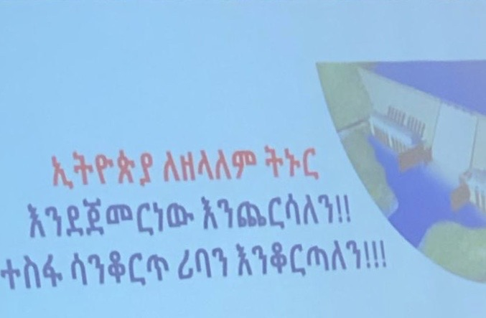
I call on all Ethiopians, as a people, not as separate ethnic groups, who live within the borders of this land to stand together as a people. The water will continue to flow from our borders to nourish many others along the way; however, we, like the people of Egypt, also want to use part of this water for the development of our beloved country. That is non-negotiable. Egypt should not be an obstacle to accessing critically needed electricity in Ethiopia. Additionally, we should make the process transparent so demands and bullying tactics from Egypt or others do not unfairly handicap the results for Ethiopia.

It is God Almighty who created us as precious people of this land. The blood that flows through our veins for generations is like the water of the rivers that flow through this country, filling the Nile since ancient times.

How can we stand together for the nurturing, wellbeing and protection of our people, not only now, but for generations to come?

How do we develop a social covenant, a common vision, based on principles that would uphold the value, dignity and rights of all Ethiopians, putting humanity before ethnicity or any other differences; and, secondly, caring about the freedom and wellbeing of our neighbors, near and far; not only because it is right, but also because no one will be free until all are free.

This also includes giving voice to concerns that could affect all the people of Ethiopia.

I am now compelled to be a voice of caution because I believe the current course of delayed action regarding the GERD may weaken our position and undermine the future interests of this nation. My hope is that this will support and strengthen the position of our leaders as they re-enter negotiations.

May God give us wisdom and strength to determine the right next steps for all parties.

Let the dam be filled and finished as planned to benefit the people and let the rivers flow and bless those who receive it!

Long live Ethiopia!
============================== // ============================
Mr. Obang Metho, is Executive Director of the Solidarity Movement for a New (SMNE) a grassroots social justice movement of diverse Ethiopians whose mission is to advance the freedom, truth, justice, human rights, civil rights, equality, accountability and reconciliation of all the people of Ethiopia, regardless of ethnicity, religion, political view or other differences.
The SMNE is based on the belief that the future wellbeing of our Ethiopian society rests in the hands of those among us who can put “humanity before ethnicity,” or any other distinctions that divide and dehumanize other human beings from ourselves; inspiring us to care about these “others;” not only because of the intrinsic value of each life, but also because “none of us will be free until all are free.”

