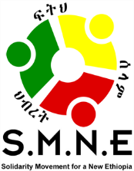

Press Conference:

“It is Time to Hear from the Ethiopian Minorities on the Current Crisis We Face!”

Do Not Forget:

They Too Have a Stake in the Shared Future of Ethiopia!

Eliana Hotel
Churchill Avenue, Piazza, Arada, 1000
Addis Ababa
Saturday, December 7, 2019
9:00 AM- 12:00 PM

The Solidarity Movement for a New Ethiopia (SMNE) will hold a press conference so as to give opportunity to hear from a panel of Ethiopian stakeholders from minority regions and/or groups. These regions/groups are commonly known to be “the others,” or under-represented in the public square or within the formalized structure of our government or its institutions.
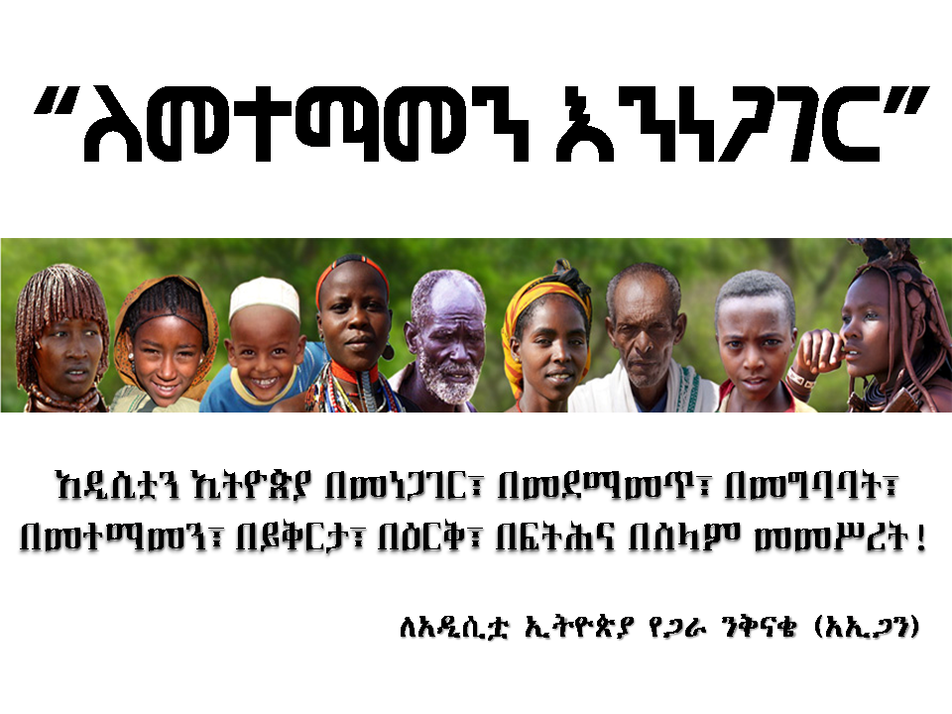
For the last thirty years, the ruling party has included four regions: Tigray, Oromia, Amhara and Southern Nations. The first three ethnic-based regions have mainly represented three of our eighty-six ethnic groups within Ethiopia, each of the three having a political party in the coalition based on the predominant ethnicity of their regions. Southern Nations, Nationalities and Peoples’ is the exception in that it is geographic in nature and home to some fifty-six different ethnic groups.

On the other hand; five regions: Somali, Afar, Benishangul-Gumuz, Gambella and Harai, and two chartered cities, Addis Ababa and Dire Dawa, have been mainly excluded from representation. Participants on the panel will come from these regions/cities and will share their thoughts on the present crisis we face as Ethiopians.

We may wonder what they might have to say about our current highly intense political situation that has given rise to ethnic-based and religious-based violence, killings, destruction and conflict? This is an opportunity to hear from them. As part of the body of Ethiopians, they have been highly impacted by conflicts among major players, as well as among others; but yet, their voices have been missing in the overall dialogue both now and in the past. What wisdom, insights and perspectives might they be able to share that could be critically important to avoiding a greater crisis in our country? What ideas and solutions might they contribute to improve the prospects for our shared future? What’s right? What’s missing? What can we do about it? When the larger, more powerful members of ethnic groups are in conflict, those on the sidelines, “the others,” must step up to help. For whatever reason, they have been marginalized in the past; however, this is not what matters now. What matters currently is for all of us to find a way to live peacefully among each other.

In the last eighteen months since the seeds of change came with the emergence of Prime Minister Abiy Ahmed and his administration, the minorities within Ethiopia have largely supported the new administration and the inclusive vision he cast for all Ethiopians. Since then, like everyone else, they have been hoping and dreaming for the constitutional and institutional reforms and meaningful reforms that would improve their lives on the ground. They are like the rest of the people. Unfortunately, under the ethnic federalism government, the widespread ethnic violence has led to the displacement of two to three million Ethiopians throughout the country, to a major slowdown on reforms and to the recent ethnic-based and religious-based targeted killing of 86 people, the burning down of churches and mosques, the destruction of property, including businesses and homes, and to the overall breakdown of the rule of law.

For example, instead of enforcing the law and protecting victims of crimes; some of the police have sided with the perpetrators based on shared ethnicity. In doing so, those responsible for upholding the law have instead become complicit, giving impunity to the offenders and becoming tools of injustice—or even a death sentence— to the innocent. Concrete action in response is still missing, causing volatile conditions on the ground that could easily boil over. In addition, both unemployment and inflation have drastically risen, leaving desperate conditions for millions of people. Food shortages are predicted as well.

This is a wake up call, warning us as Ethiopians that the country could go the way of Rwanda. With the rising ethnic extremism, what steps must be taken to protect Ethiopia from becoming the next failed state?

With all of this in mind, these minority groups and regions will not remain silent. We will have six speakers at the Press Conference on Saturday from Somali, Afar, Benishangul-Gumuz, Gambella, Harai and Dire Dawa. It is time to listen to what they have to say; not only as they express their concerns, but also as they contribute to the discussion as to how we might work together to address these challenges in a peace-building and civil way.

Currently, they have been encouraged by the proposed amendments to the previous ethnic-federalist framework which would be far more inclusive by including all regions within that party; however, that is not good enough. First of all, there is already unresolved resistance coming from within the party and we do not know the outcome. Secondly, we need to be thoughtfully examine what governmental structures will lead to the best outcomes for our country. This will require listening to different perspectives, open dialogue and careful examination to decide on the best way forward.

It is time for these minority groups to speak out and work for the betterment of all, believing they share in the ownership of the country. The basic premise for peace requires every citizen and every group to seek for others what they want for themselves. What is good for me is also good for you.

We all have a stake in this. Truth is essential. The failures of our past should not be denied; yet, they should not be allowed to destroy our future. How can we unify our country by what we have in common as human beings, rather than by what divides us unnecessarily, like ethnicity? We are more than this.

We are human first, created equal by God, and by being human, we have a responsibility to care not only for oneself or for one’s own group; but, we are to care for others as well.
As humans, we are endowed by God with value, worth and purpose. God has also given us a conscience so we know the difference between good and evil, which should direct us not to kill, rob, destroy or commit crimes against others.

By being human is to be given a choice; hopefully, to choose to follow the moral, righteous way and to care for others. Why? It works for the good of the individual, community, society and nation. It creates the environment for human flourishing. Laws and enforcement are hardly necessary when it is carried in the heart of a human being. When we fail, we should attempt to correct ourselves and learn from our mistakes or wrongful acts or attitudes. Seeking forgiveness and giving forgiveness are a shared part of the human journey. These are God-given these responsibilities for which we will be held accountable in this life or the next.

These minorities are now calling us to join the “I’m Human Movement” and to help prepare the ground for a harvest of freedom, justice, peace, stability, and human flourishing. Become the blessing you seek. Contribute to peace in our nation as we treat the person we meet as we would like to be treated.

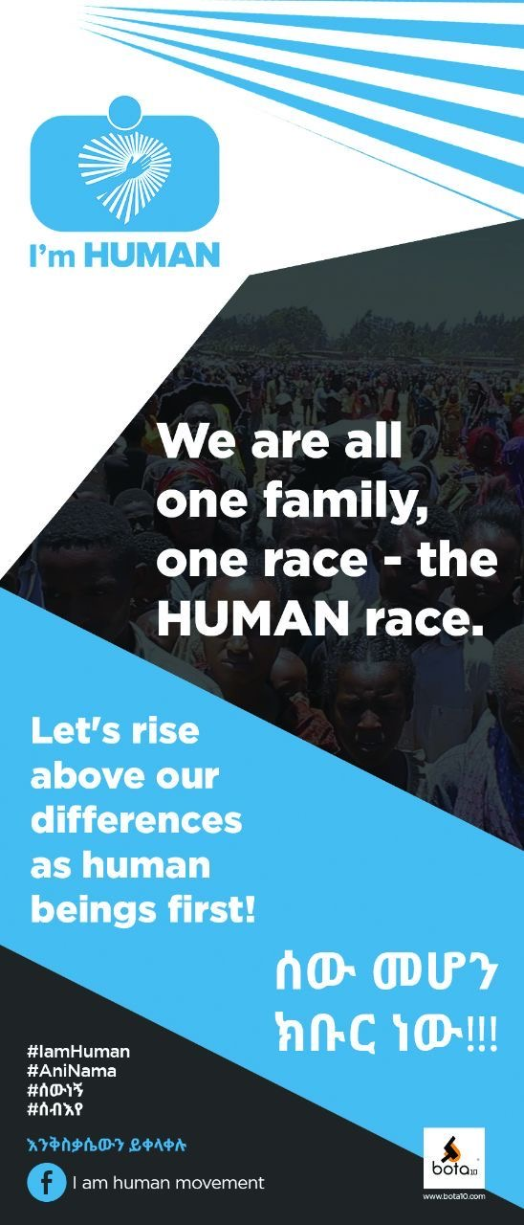

These minorities will be sharing their ideas and thoughts at this press conference coming up this Saturday. Following this press conference, they will call a National Stakeholders’ Conference for all stakeholders. More will be shared about this.

May God help us at such a time as this to put humanity before ethnicity or any other differences; and, to care about others, not only because it is right, but also because no one is sustainably free until all are free! Let’s start talking to each other, not about each other.

Please join us for a stimulating discussion!

For Information Contact:
Mr. Obang Metho,
Executive Director of SMNE
Email; obang@solidaritymovement.org
Website; www.solidaritymovement.org

