I’m Human: Today is the Day to Join a Movement for Humans

November 24, 2019

On Sunday, November 17, 45,000 Ethiopians participated in the Great Ethiopian Run in Addis Ababa. Mr. Obang Metho, the Executive Director of the Solidarity Movement for a New Ethiopia (SMNE) was one of the participants in that race. He wore the official T-shirt similar to all participants; however, at the finish line of the race, as planned by some of the youth leaders in the organization, Obang removed his race T-shirt to reveal a different one. On the front of that shirt was written in Amharic: “I’m Human.” 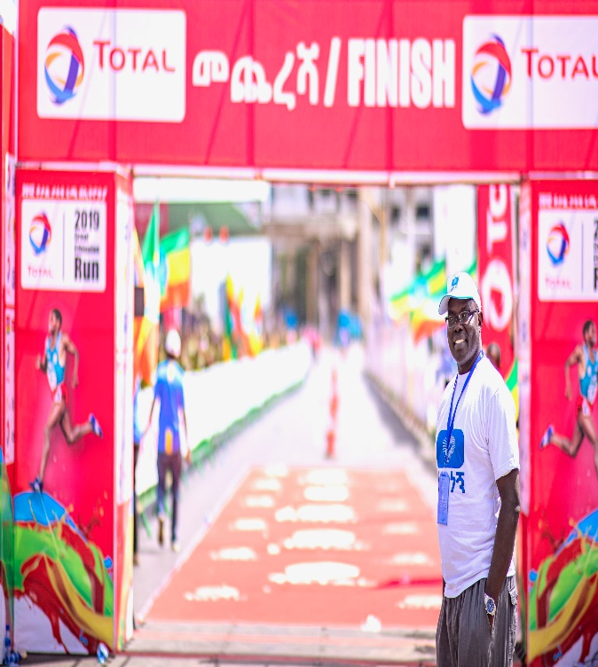 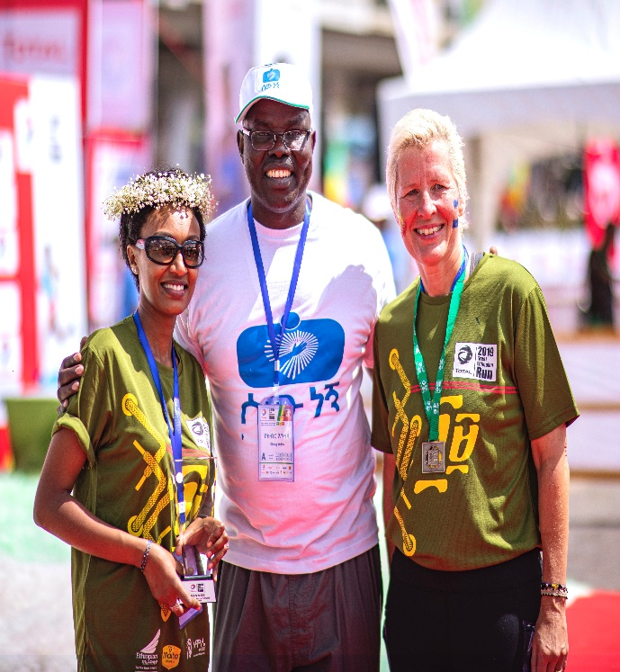
Everyone got it. Why? It not only confronts today’s reality that has resulted in a shocking rise of ethnic violence and conflicts, but it also points to Ethiopia’s 30-plus-year history of the politicized, divisive and self-centered exploitation of ethnicity/tribe in Ethiopia, used to advance the power and self-interests of a dominant group or the elite of that group over others. The idea and the phrase quickly went viral, spreading via the social media and by word of mouth.
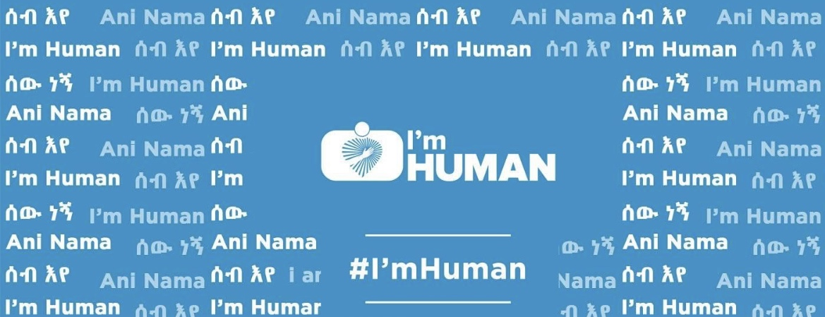
Following the race, Mr. Obang was invited to attend an event featuring esteemed speakers, a poetry and literature night at the national theater. Most of the main speakers, chose to focus on this same phrase, “I’m Human,” one speaker, concluding his remarks by calling on all present to start a large-scale “I’m Human Movement” of the people in Ethiopia.
The overall response to the “I’m Human Movement” has been overwhelmingly positive and is expanding; however, others are reacting negatively. For example, one person wrote: “I don’t want to be a human, I am [his ethnic group first]. We don’t want it.” Another person said, ‘“Who came up with this [expletive] “I’m Human” thing?” We don’t need it. Make sure our young people don’t hear about it!”

Right now in Ethiopia, we are witnessing an atmosphere where fear and tensions of ethnic based violence have reached an all-time high. It is not what we hoped for after the emergence of the new administration under Prime Minister Abiy Ahmed, who recently was awarded the Nobel Peace Prize. However, there are ethnic extremists and ethno-nationalists from many different groups who want to steal his vision and replace it with their own that does not embrace the wellbeing of all. They also seek to mislead those within their own groups in order to advance their own ethnio-nationalists agenda, which is self-interest and ethnic interest.

Instead of national reconciliation, peace and increased unity, Ethiopians have been horrified by the worsening ethnic-violence seen in the country that has resulted in gruesome killings of 86 people, the burning of 30 churches and 2 mosques, the destruction of property and the forced expulsion of many from regions where their ethnicity did not match that of the mainstream population.

The failure or resistance to move beyond ethnicity to affirm the humanity of others is an alarming indication of the danger ahead in Ethiopia, a danger which could affect all of us. If you recall, it is what preceded the genocide of over 800,000 Rwandans. The world said, “Never again!” How can we say, “Never” to such a large scale disaster in Ethiopia? This is what the “I’m Human Movement” is about. The “Never” must come now before it is too late and must come from all of us.

Background:

The “I’m Human Movement” has evolved from nearly 16 years of work to change the way we value the lives of others outside our own groups in Ethiopia. It began as a result of December 13, 2003 Massacre, when more than 400 Anuaks were targeted and massacre based ethnicity in Gambella town to be “taught a lesson.” According to Human Rights Watch Report of March 2005 Vol. 17, No. 3(A) titled: “Targeting the Anuak: Human Rights Violations and Crimes against Humanity in Ethiopia’s Gambella Region”. “ENDF soldiers and highlander civilians launched a brutal attack on Gambella town’s Anuak population. The commander of Gambella town’s military garrison, Major Tsegaye Beyene, was in Gambella town throughout the massacre and took no apparent action to stop it; indeed, he appears to have directly taken part in the violence”.

The bloodshed of that day did not start or end with the Anuak, but has involved many other groups as well. It led to the formation of the Anuak Justice Council and then to the SMNE and its foundational principles that could free a society to flourish and prosper. They are:

- HUMANITY BEFORE ETHNICITY OR ANY OTHER DIFFERENCE:
Do we need to be reminded that we did not create ourselves? Neither did “ethnicity” create us. It was our Creator who created us as human beings. God is the one who values and loves every one of us; in fact, even more than we value and love ourselves. Self-centered-love of ourselves is not like God’s love for us in that He wants what is best for us whereas we often fail to do the same. He loves others in the same way. Our Creator brought us to this world for a reason—not to kill or to be killed. However, if we believe we created ourselves—or live as if we did— we will rebel against what is right and fail to resist what is wrong, setting up our own self-serving rules. It becomes all about “ourselves” or how others, even those from our own “tribe,” might be used or bullied to further our own personal ambition for power, wealth or position. Yet, it is the truth that matters.
In almost every tribe in Ethiopia, from early times we recognized from the world around us that there was a Creator. We did not create ourselves, meaning we are accountable to our Creator.

In the Bible God said: “bloodshed pollutes the land.” Our land is already polluted with bloodshed and we are seeing the consequences of that on victims, perpetrators and bystanders. Has God given us an opportunity to break this curse on our land? As our tribal thinking is bringing us to a point of desperation, genocide and possible disintegration, how can we choose to live God’s way and see the restoration of freedom, justice, peace and prosperity to our land? Without the first three, there can never be prosperity; instead, we will only see in endless poverty and underdevelopment regardless of any foreign aid.
- NO ONE WILL BE FREE UNTIL ALL ARE FREE
In a healthy, well functioning society, we uphold the rights of others like we seek the same for ourselves, knowing our own freedom and rights are most secure when they are inclusive. Likewise, when we care about our neighbors as we care about ourselves regardless of their ethnicity, it creates a societal foundation where people and communities can flourish and prosper. When we fail to do so, problems develop. When a society and government not only fails to do so, but oppresses its people, such a society will ultimately implode. This is what we are now facing, causing none of us to be free.

Ethiopia’s ethnic federalism was socially engineered, in 1992 to silence most of the 86 ethnic groups in Ethiopia and give nearly total advantage to one ethnic group, but not the whole of that group. In particular, it benefited those at the top of that group who caved into the temptation of self-interest and exclusion of others. In other words, it gave license to these few to exploit the system for their own benefit and did NOT include all within their ethnicity. That’s the way these efforts go; make promises to the “masses” so they can be used as your “currency” in order to exploit their support for your own personal ambition and advancement. It's a characteristic of Marxist-Leninist Fascism as well as the tribalistic ideology, gone wrong, under which we live today.

The effort was accompanied by oppression, theft, injustice, corruption, death and the crushing of any resistance in order to maintain control; however, what is now being harvested has come from the seeds planted—ethnic hatred, division, and violence. Thirty years of this kind of exploitation has reached to the point that it is now threatening genocide and the survival of everyone in Ethiopia as well as the existence of Ethiopia as a country.

Resistance has come from groups mostly operating for their own freedom without realizing that no one is sustainably free by themselves. It is a hijack of the promises and hopes we shared just over a year ago when Prime Minister Abiy came to power. What can we do to help him so this vision cannot be sabotaged by ethnic-nationalist or ethnic-extremists?

III. LET’S TALK TO EACH OTHER NOT JUST ABOUT EACH OTHER
The only way to reclaim our freedom and lasting peace in Ethiopia is to go back to the basics—I am a human and so are you, created equal and to be loved, nurtured and valued as a human being. Each of us is also created to live out our God-given purposes and responsibilities and to contribute to the betterment of others human beings—especially our neighbors, but even our enemies; or, those we “assume” are our enemies.

Being human carries with it responsibility; and sadly, that has been sabotaged by the toxic environment in which we now live. Ethnic federalism, ethnic cronyism, and ethnic extremism have contributed to the dehumanization of others, dividing and isolating us from each other.

In Rwanda during the genocide, Hutu and Tutsi students at one of the schools were remarkable for refusing to participate, even as guns were pointed at them. When commanded to identify the ethnicities of others, they refused, despite threats. Gunmen killed one of the young women, trying to incite them to turn on each other. They still refused. The gunmen then started shooting others and everyone ran, but many were saved. Their resistance to violence has led many to wonder and examine what made the difference? The short answer ended up to be that the human relationships between them connected them as human beings first, rising above their ethnicity despite their divided culture.

Could talking to each other rather than about each other improve those human connections enough to give us the strength, courage and conviction to resolve our conflicts in Ethiopia without violence?

We the people of Ethiopia have been reduced from what God intended for us and the result is now being seen as a neighbor kills another neighbor and student kills another student. We see the devaluing of human life, the destruction of property, the absence of the rule of law, the blocking of roads or destruction of opportunity, the lack of respect towards others and the failure to help others. This cannot be a “blame game” against another group; for we have all failed in many ways, but let us heed the warning signs before our failures lead to our mutual destruction. Our existence in this century is being threatened like someone in a burning house. No one has time to focus on who started the fire; but instead, a shared effort should be made to stop the fire.

Can we recognize the humanity in others, not selfishly picking and choosing to exclude or include membership into one’s own “self-defined tribe of worthy human beings” based on one or more favored parts of our own multiple sub-identities—like ethnicity, language, culture, nationality, gender, religion, skin color, age, ability or disability, socio-economic level or political view?

If we deny life, liberty and dignity to others, we can be assured that security, peace and prosperity will escape us and possibly lead to mutual destruction. In light of this, how can we build enough stability to work out the challenges before us? We must be willing to talk to each other.

Will you join the “I’m Human Movement?”
Even when the law of human kind breaks down; there is still a greater law that exists from our Creator to not take the life of another human being. This is what makes us human. We cannot avoid the responsibility or accountability for we know the difference between right and wrong. Our consciences can direct us.
Where mass atrocities have taken place throughout human history, too many give in to the pressure and end up joining in or turning a blind eye to that evil thing around you. Look what the conscience of one man achieved during the Holocaust when he saved so many Jews from certain death. His main regret was not saving more lives—even one more. His actions were portrayed in the movie, Schindler’s List. He did not forget his human responsibility towards others.
Are we obsessed with ethnicity, like food (injera), or are we looking for what it can give us—power, easy loans, wealth, land, resources, foreign bank accounts and privilege where we have not earned it, but forced it from the hands of others? We might rationalize that these others are not using it, but why are they not using it? Is it because of structural deficiencies due to blatant favoritism and others to marginalization in order to exploit them? For example, the land grabs in Ethiopia were partly facilitated by easy loans for regime cronies who ended up taking the money and never investing it in the land—with no consequences.

Ethnicity continues to be seen in Ethiopia as the ticket to power and riches by some. This is hypocritical as many are of more than one ethnicity. Additionally, many gained power by protesting against a regime who advanced the same ideology. It has also been justified as payback time for past grievances. Will the horrible acts we have seen in recent weeks and months serve to fuel the next cycle of victims? This is a recipe for perpetual defeat, violence and poverty.

No wonder some think the solution is to separate from the country; however, that is short-sighted. How can we be isolated in this global world? Will it provide needed jobs for our youth? Who will buy their goods? How will they transport their goods to the market and how will needed goods to improve their economy and their livelihoods be obtained?

Right now, more than ten ethnic groups from the southern Ethiopia have voiced the same desire to have their own regional states. Is it because they believe it is the only way to find security, freedom and justice for themselves? Is it not better for all of us, big, medium or small, to work together to secure freedom, justice, peace and prosperity for everyone?

The grievances of our fellow Ethiopian brothers and sisters should not drive us apart, but should become a bond that inspires us to work together to create a different kind of nation because we are willing to let go of past bitterness and nobly demand a movement of the people for a better Ethiopia for all.

We cannot see any other way to save this country without being aware of our responsibilities given to us by our Creator, to be a good neighbor to all the people of Ethiopia and beyond, and acting on it. Our Creator has called us to something better; but, we have resisted and rebelled against His ways too often in the past—ways that can bring meaningful reforms to our country. Let us listen now with new ears, minds, hearts and souls to the truth that will set us free and then let us take action.

A Call for Action
People cannot wait, hoping for a solution to come from somewhere else. We the people must organize, engage and mobilize to become the solution. Anyone who agrees with this movement should become part of this “I’m Human Movement” for all of us. It is a call to take personal responsibility for the betterment of our beloved country of Ethiopia.

You are called to this movement:

- If you are someone who is afraid for our safety; its yours.
- If you are against violence; join us.
- If you or your family are of two or more ethnicities, you are part of this.
- If someone in your family, community or those in your faith group face persecution; this movement is for you.
- If you are parents or grandparents who care about the future of your descendants; this is your time.
- If you are a youth who wants a better future; you are part of this.
- If you are someone who has witnessed the rising ethnic hatred; this movement is yours.
- If you know family and friends who have suffered now or in the past; it is your time.
- If you are someone who knows your responsibility to help others; you are part of it.
- If you see what is happening as wrong and you believe in righteousness and good, even though we all fall short; this is for you.
- If you see a future with no opportunity unless you are in the “right group”; this is for you.
- If you are a human; this is for you.

So, if any of these describe you, this is your movement. This is your call to action. This is the time to reach out to those around you to organize in small groups—as family, friends, fellow students, community members, elders, people of faith, members of a church, mosque or synagogue, association groups or other informal or formal structures of society, both in Ethiopia and beyond. Cross bridges of differences. Reach out to others to build relationships and trust. Advance morality, righteousness, justice and freedom for all. Engage in informal and structured dialogue, research and study, next steps and upholding an equitable system of justice.

One of the most common struggles is because many Ethiopians are not one ethnicity, but a mix of two or more. Your grandmother might be of one ethnicity that is in conflict with that of your grandfather. Why do you have to choose? The same could be the case of other identity differences. At the end of the day, it comes back to one thing, we are all one family, one race— the human race. Listen to your consciences.

We should not be pushed by the ethnic extremists and ethno-nationalists who want us lose our morality and humanity in a rush of crazy emotion and violence like we have recently witnessed. We are better than this. We must reject this kind of thinking and action if we want greater security and wellbeing in Ethiopia. What we have in common is: “I’m human and so are you.” People recognize this.
As you organize, engage and mobilize, agree to talk about the issues that are a threat to all of us. All of us want peace and harmony. No one wants our descendants to inherit intergenerational hatred and bitter vendettas. We can work together to build a better society. If anyone has a dream for better education, better roads, better healthcare, more and better jobs, access to clean water, adequate food, access to land, or ways to better the lives of the people; this is your movement. It is for you and for the future of the next generation.

The “I’m Human Movement” is yours to own. It is a call to save lives, to revive a dying society and to rebuild our nation. Organize and start the work and we will go forward to connect all these cells of commitment as best we can. Everyone has to do their share.

This movement will help bring about the advancement of an inclusive and humane vision for Ethiopia, and will also support the vision as laid out by Prime Minister Abiy that brought such an enthusiastic response a year ago. May God help us to use our humanity— our greatest common bond— to save us from each other.
Become the voice of reason to speak up for all of us. May God bless our nation

For more information, contact us at: Teamleader@Iamhumanmovement.com or Mr. Obang at Obang@solidaritymovement.org

For more information, you can refer to the book, Reconciling All Things: A Christian Vision for Justice, Peace and Healing, co-written by Dr. Emmanuel Katongole, a Rwandan, and a Professor of Theology and Peace Studies at the University of Notre Dame and Chris Rice, both who are also co-directors of the Center for Reconciliation at Duke Divinity School.

