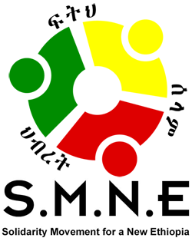
Remembering the Anuak Massacre:
Begin by Lighting Your Candle and then Your Neighbor’s Until Our Candles Bring Light Over Our Nation

PRESS RELEASE

December 13, 2018. Addis Ababa--.Today, December 13th, will mark the fifteen year anniversary of the beginning of three days of killing and destruction in Gambella, Ethiopia that was carried out by TPLF/EPRDF national security forces, backed up by civilian militia groups they had armed with machetes. The Anuak people were targeted, especially leaders and those who were against the TPLF political repression and opposed to the federal government plans to explore oil on their indigenous land without following the legal process as set up in the Ethiopian Constitution or as required in international law regarding indigenous peoples’ rights. There was also a long-term plan to exploit the abundant fertile land and untapped natural resources.
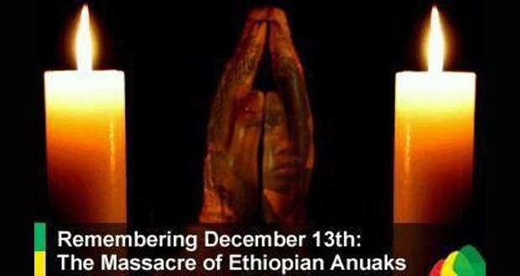
In less than three days, 424 Anuak were killed. The Anuak continued to be targeted for nearly three years. By that time, over two thousand had been killed and many more human rights atrocities committed, including being jailed, tortured and driven by the thousands to seek refuge in neighboring countries like South Sudan and Kenya. The limited infrastructure in Gambella was largely destroyed, equipment and supplies were pilfered from clinics and schools, and homes, crops and granaries were burned.

At the time, few Ethiopians heard about it. Under some international pressure, former Prime Minister Meles Zenawi opened an investigation, but the results were a whitewash, including minimizing the numbers that lost their lives. The report basically blamed eleven soldiers in the national defense forces. Subsequent investigations by Genocide Watch determined that the killing came out of an actual plan, Operation Sunny Mountain, meant “to teach the Anuak a lesson” regarding their resistance to the exploration of oil project and other government plans to exploit the region for their own, not national, interests. According to the report, the plan began in the top offices of the government. Human Rights Watch and others completed a number of additional reports.
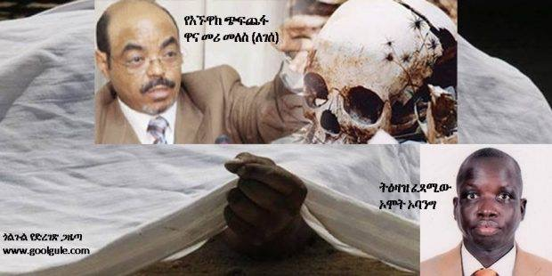
Since 2003, Anuak throughout the world have held special services to commemorate this day when so many lost their lives; however, the Anuak of Gambella have been denied the right to publicly do the same as the massacre is not to be talked about. However, this year on September 17, 2018, a team from the Solidarity Movement for a New Ethiopia (SMNE) visited Gambella and for the first time, it was publicly acknowledged. This God-given miracle arose unexpectedly from inside the government when Ethiopia’s new prime minister, Abiy Ahmed emerged in April of this year and set a different course for the country.

In a public ceremony, attended by thousands of people, the SMNE team found four local people to read the names of each of the 424 victims of the December 13-15, 2003 massacre. This had never been done before.
The SMNE team also showed a short video about what happened at the time, including a testimony from both a witness and a survivor, and also the after effects, giving the people some acknowledgement of this painful issue, leading to some healing and a degree of closure after all these years of being denied the opportunity.

However, this week there will be no public acknowledgement for a variety of reasons. One reason is that it may take additional time for people and public officials to venture into this new era where open public discussion is seen in a more positive light. Secondly, it continues to set off a fear response among some.

As a result, there is a strong tendency to block opportunities for dealing with the many unresolved issues that are still creating inner conflicts and upheaval at the surface. For example, if we are to stop the ethnic violence going on throughout Ethiopia, we must face the issues and the history. We must listen, acknowledge the truth and figure out how to bring greater justice to all of us. It will take work and may not be easy, but what is the alternative?

Look at our universities campuses. Unresolved ethnic conflicts continue to make it difficult for our students to feel safe and secure, especially those living outside their ethnic areas, but as a result, it is hampering normal campus life. Freedom of mobility has diminished due to fear of violence for those working, living or even traveling to other parts of Ethiopia outside their own areas. Ethiopia now is said to have 1.8 million internally displaced citizens in the country. How can we advance as a society under these conditions? How can we hold an election? How can we collaborate in multiple ways necessary to bring greater learning, services, products, development, prosperity and flourishing to Ethiopians if we become prisoners of our own communities?

There is hope in Ethiopia. For the first time, we have a federal attorney general who is strong and bold in facing the truth. He has openly revealed and held accountable some in the current power structure responsible for gruesome and inhumane torture, killings, violations of human rights and corruption. In the past, those who revealed the truth were called anti-government and often imprisoned. We have been exposing some of this as people; but now, for the first time, we have some top level government officials who are admitting to past human rights violations and other acts of injustice. This is very commendable. Another example is our new Supreme Court Chief Justice, Meaza Ashenafi, who was harassed in the past by former government officials, but now is leading the way forward in restoring justice.

As the Anuak people and their friends in Gambella seek a public platform to remember this fifteenth anniversary of the Anuak massacre; they are still facing resistance from those who fear that the sensitivity of the issue will create too many problems that they are not equipped to deal with during this period of transition. It may be an over cautious position; yet, there is much work to be done by the people of Gambella to make ready the way for next year’s anniversary to be a celebration of the progress of justice, peace and greater prosperity. Eventually, we hope to build a memorial site with the names of the victims where people can visit, pay respects and lay flowers.

A tragedy can become a turning point towards a better Gambella. The same is true throughout Ethiopia. We Ethiopians have suffered in many places. We have been mistreated; and in turn, we have sometimes mistreated or looked down on others in different ways. Can the peace of our future begin within each of us?

In the next year, how can the people of Gambella and Ethiopia better love their neighbors? The same would apply to those Ethiopian in the Diaspora. How can people come together, united by a desire for a better Ethiopia for all?

Our people are religious and many speak of prayer as being important to them; so how can people come together to pray for each other, for the people of every region of the country, for the government, for the strengthening of Ethiopia’s public and private institutions, for forgiveness, peace and reconciliation among the people, for greater prosperity and diminished corruption? Many are struggling to live, to find restored hope and to find security. Can each of us be used to bring light out of the dark times we have experienced?

Yes, let us remember this fifteen years anniversary; however, remembering our darkest days is not enough. How do move forward to help bring a brighter future? The opening up of our country this past year, including having a prime minister who speaks for human rights, justice, accountability and freedom for all, is an answer to the prayers of many Ethiopians throughout the country and world. As a next step, we hope PM Abiy will establish an independent human rights abuse investigation body that will investigate all the human rights crimes that have been committed across the country in the last decades.

People want to know what happened to their family members and who was responsible. This will lead to greater peace, acceptance and harmony. It should also be followed with the construction of a memorial for all these victims who suffered unjustly. Then, the next generation can visit and learn what we Ethiopians have done to each other so it will never happen again. This opportunity could only come through the work of God, giving new possibilities for a brighter future. However, we the people cannot sit by and do nothing. We need renewal ourselves.

Take this opportunity to become an instrument of peace—to help bring light out of the darkness rather than to cover it; to give love and forgiveness—sometimes undeserved— rather than holding on to bitterness and hatred; to seek solutions to wrongs and injustice rather than putting ethnicity, greed and self-interest ahead of what is right; to speak the truth for it will set us free from the rotted strongholds where lies and deception have taken over; and to light a candle, wherever you are, so you can light someone else’s candle, and they another person’s candle until there is a greater and brighter light shining on our beloved land.

Light your candle and become part of the movement to re-humanize Ethiopians from the darkness of tribal hatred and ethnic-based politics that is based on greed, exclusion of others and which lacks a vision for an inclusive nation.

May God help us be people of change who can see the humanity in our neighbors, becoming ambassadors of reconciliation, peace, civility and prosperity. May God bless Ethiopia!

